**2011 TORNADO SEASON**

**(RUNS APRIL THRU JULY)**

**ARE YOU PREPARED??**

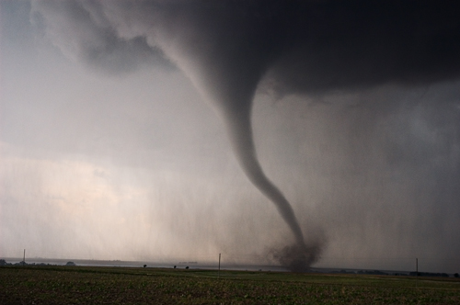

**Without much warning, Mother Nature can huff, puff, and blow your entire town all the way over into the next county. Tornadoes are downright devastating when they hit populated areas. While they can occur at any time of the year, springtime is the beginning of the peak tornado season.** [**Daddy Bear and his family take tornado warnings very seriously and have a well-rehearsed plan.**](http://daddybearden.blogspot.com/2011/02/my-day-so-far.html)  <http://daddybearden.blogspot.com/2011/02/my-day-so-far.html>  **Even if your house is left standing, a tornado can leave you without electricity and potable water for many days. Police may prevent you from leaving or entering your area. If you need help setting up your contingency plans,** http://www.ready.gov/america/beinformed/tornadoes.html